Project 1: Deploy a Static Website on AWS

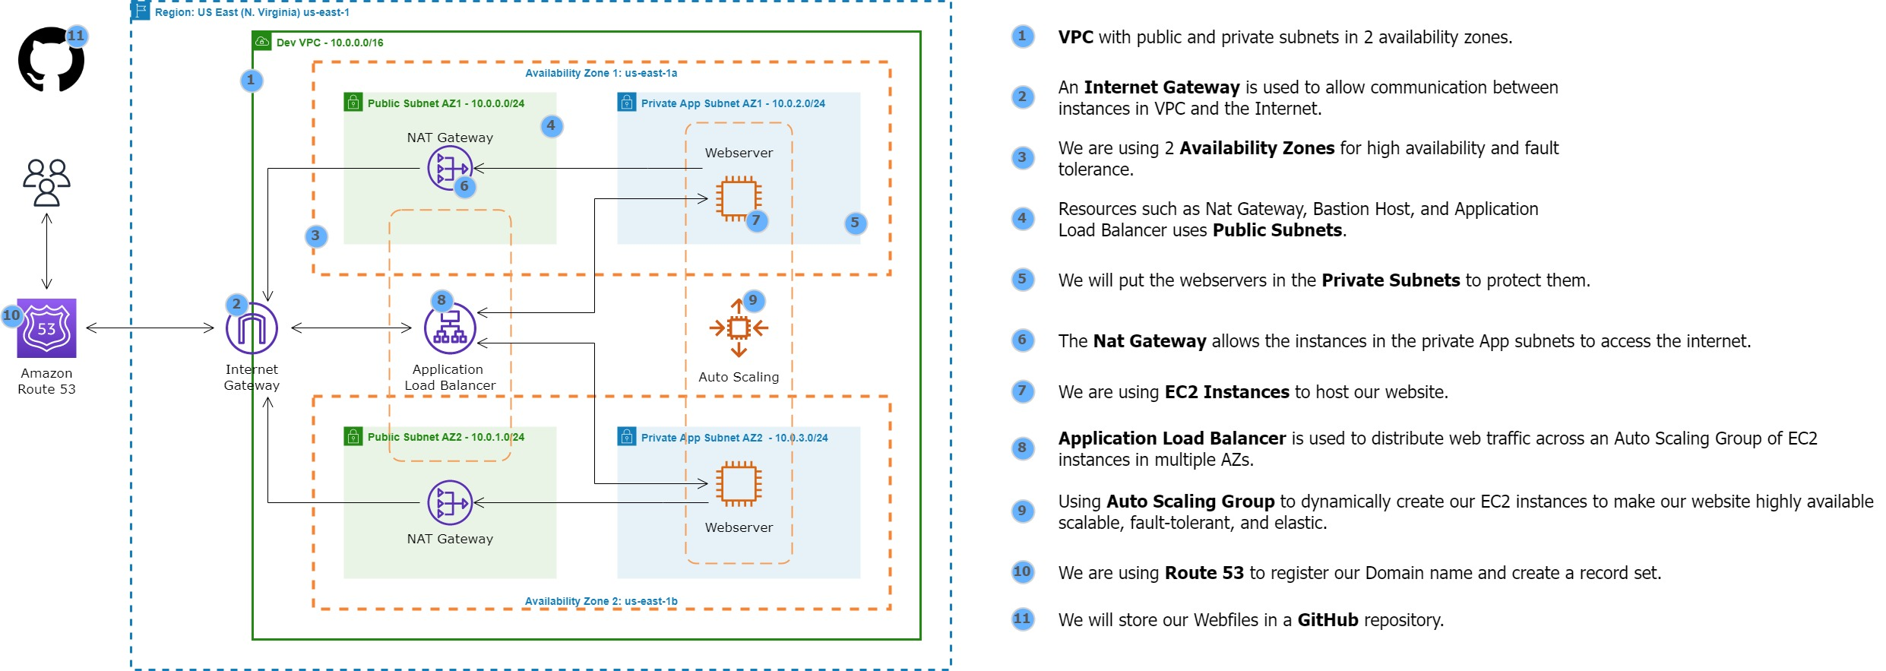

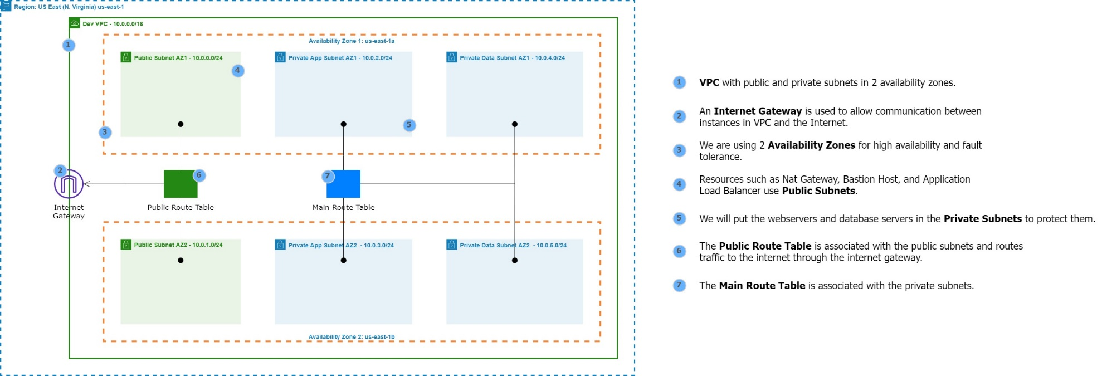

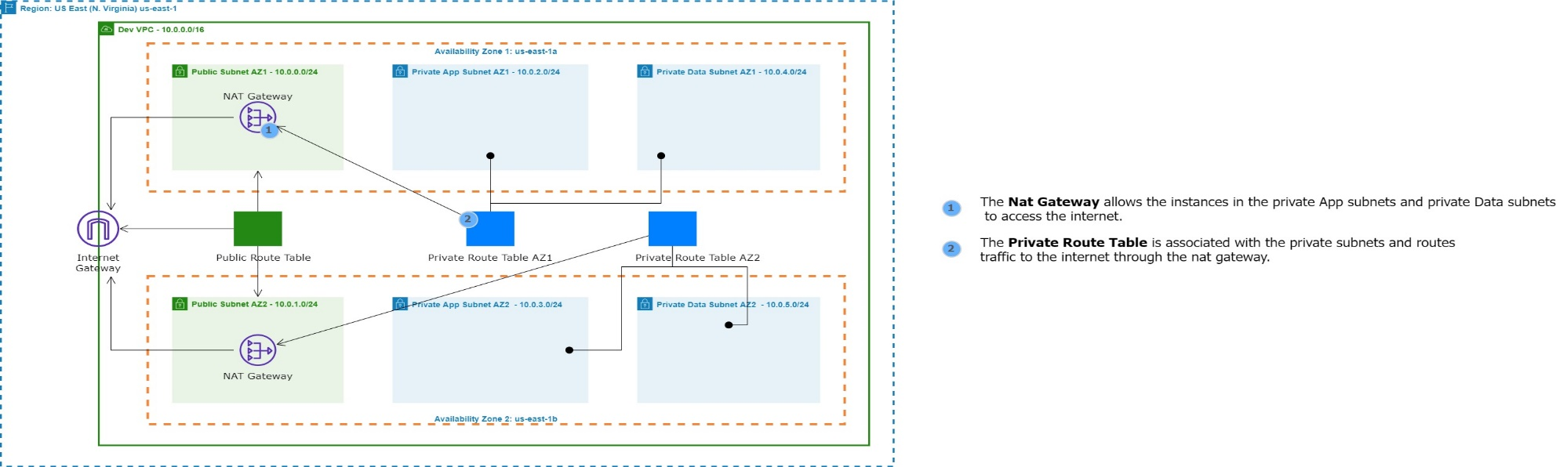

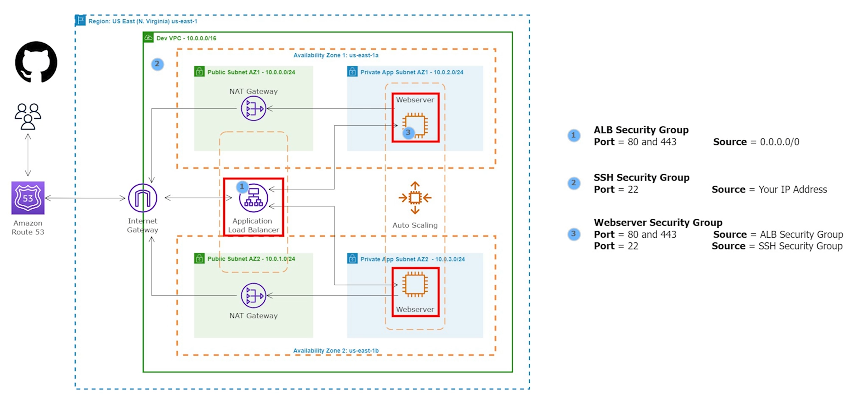

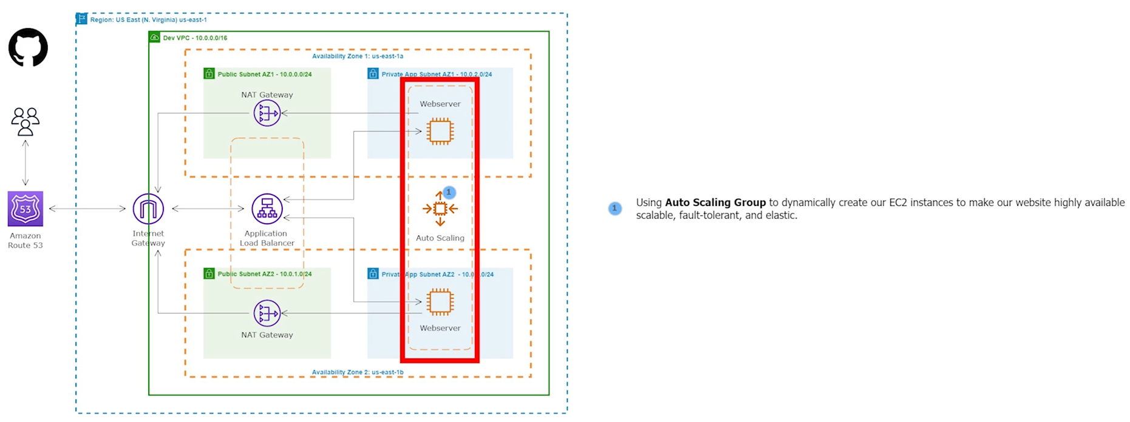

Project 3: Deploy a WordPress Website on AWS

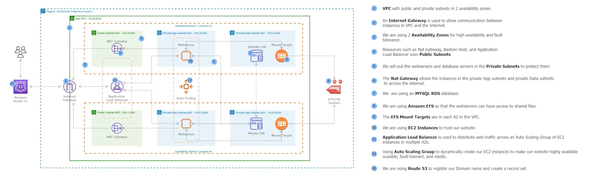

Project 6: Deploy a Dynamic Website on AWS

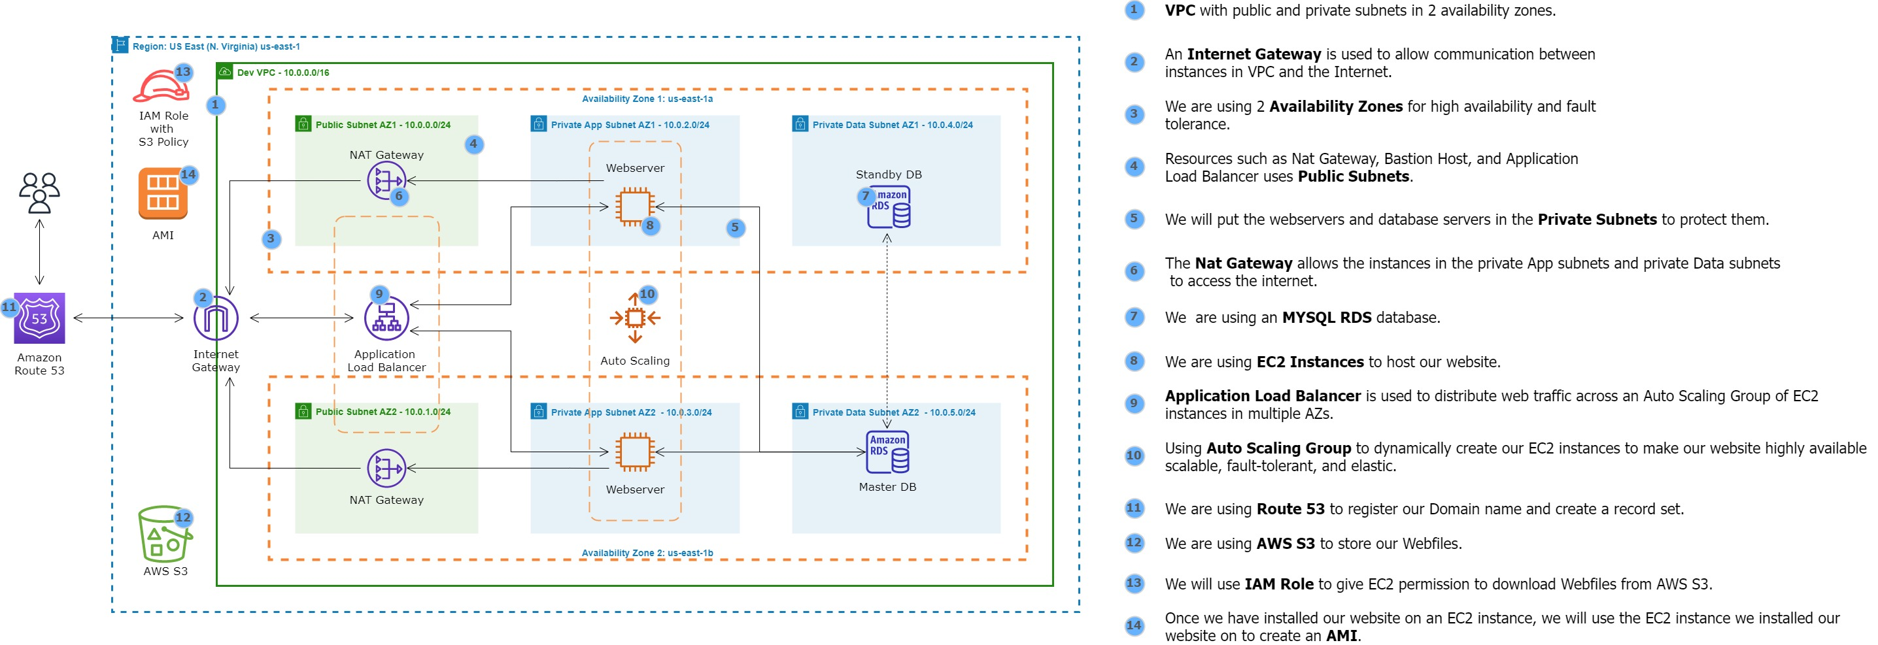

Project 8: Deploy an E-commerce Website on AWS with Terraform

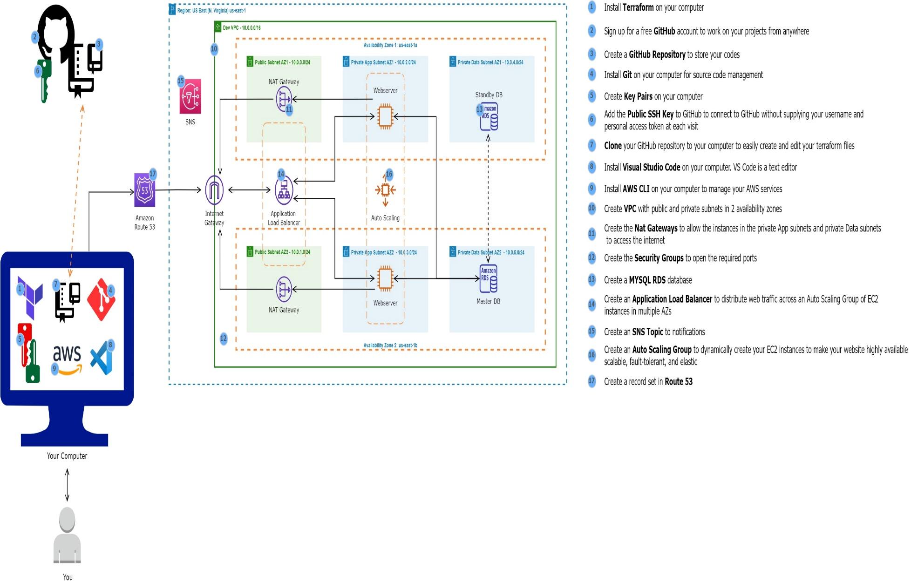

Project 9: Maven, Jenkins CI Job

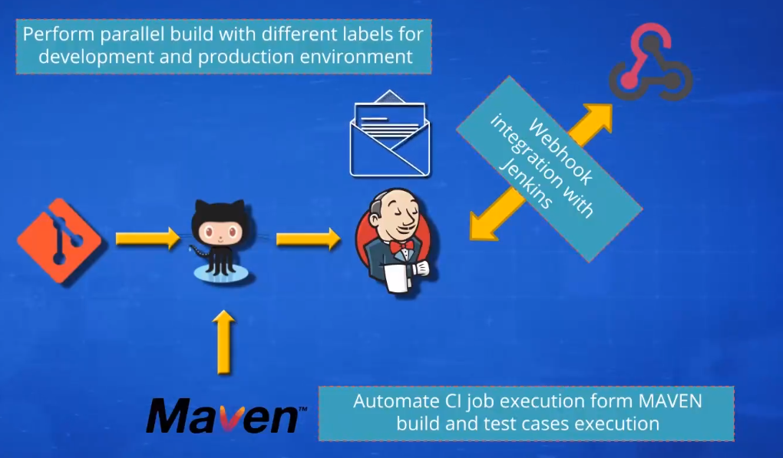

Project: SonarQube

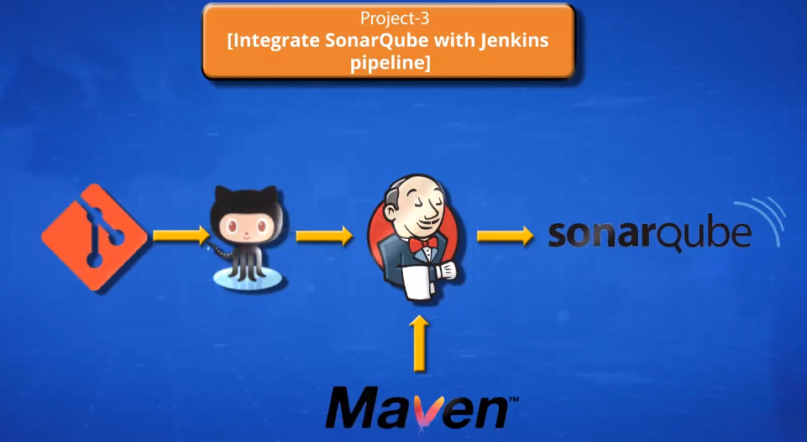

Project 10: CICD Tomcat Integration

Project 12: CICD Jenkins Ansible Docker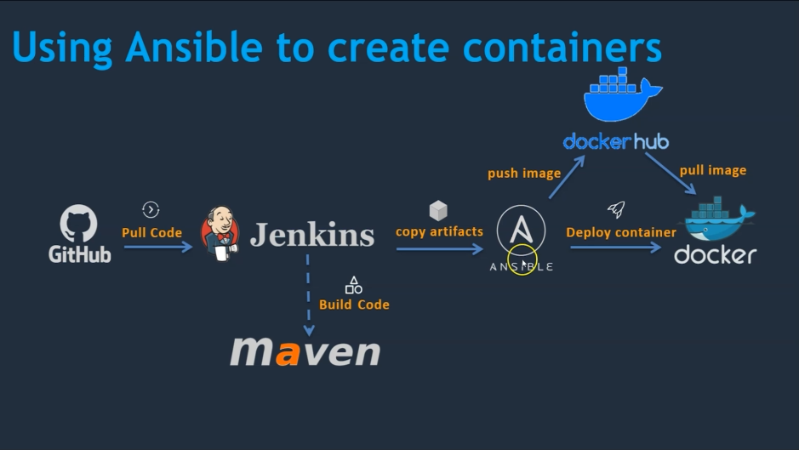

Project 13: Deploy a Static Website on AWS with Docker, ECR

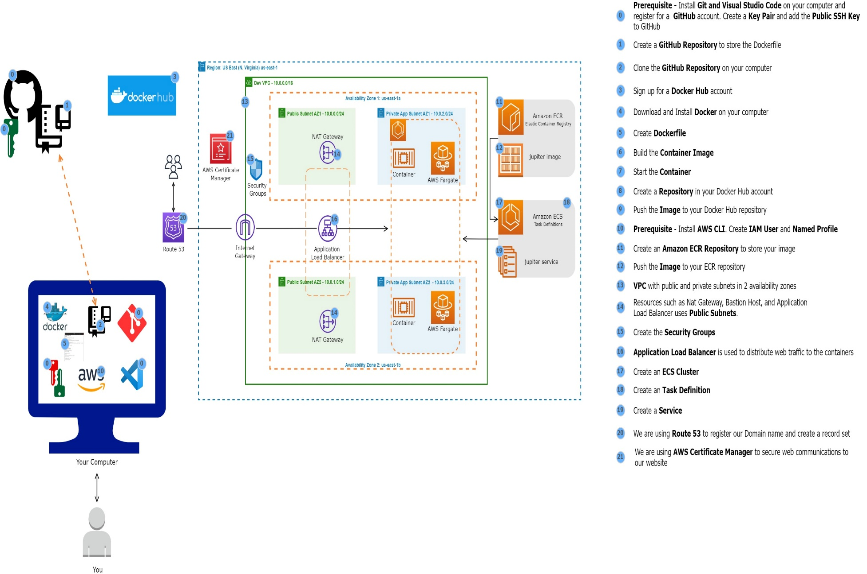

Project 14: Host a Dynamic Web App on AWS with Docker, Amazon ECR, and Amazon ECS

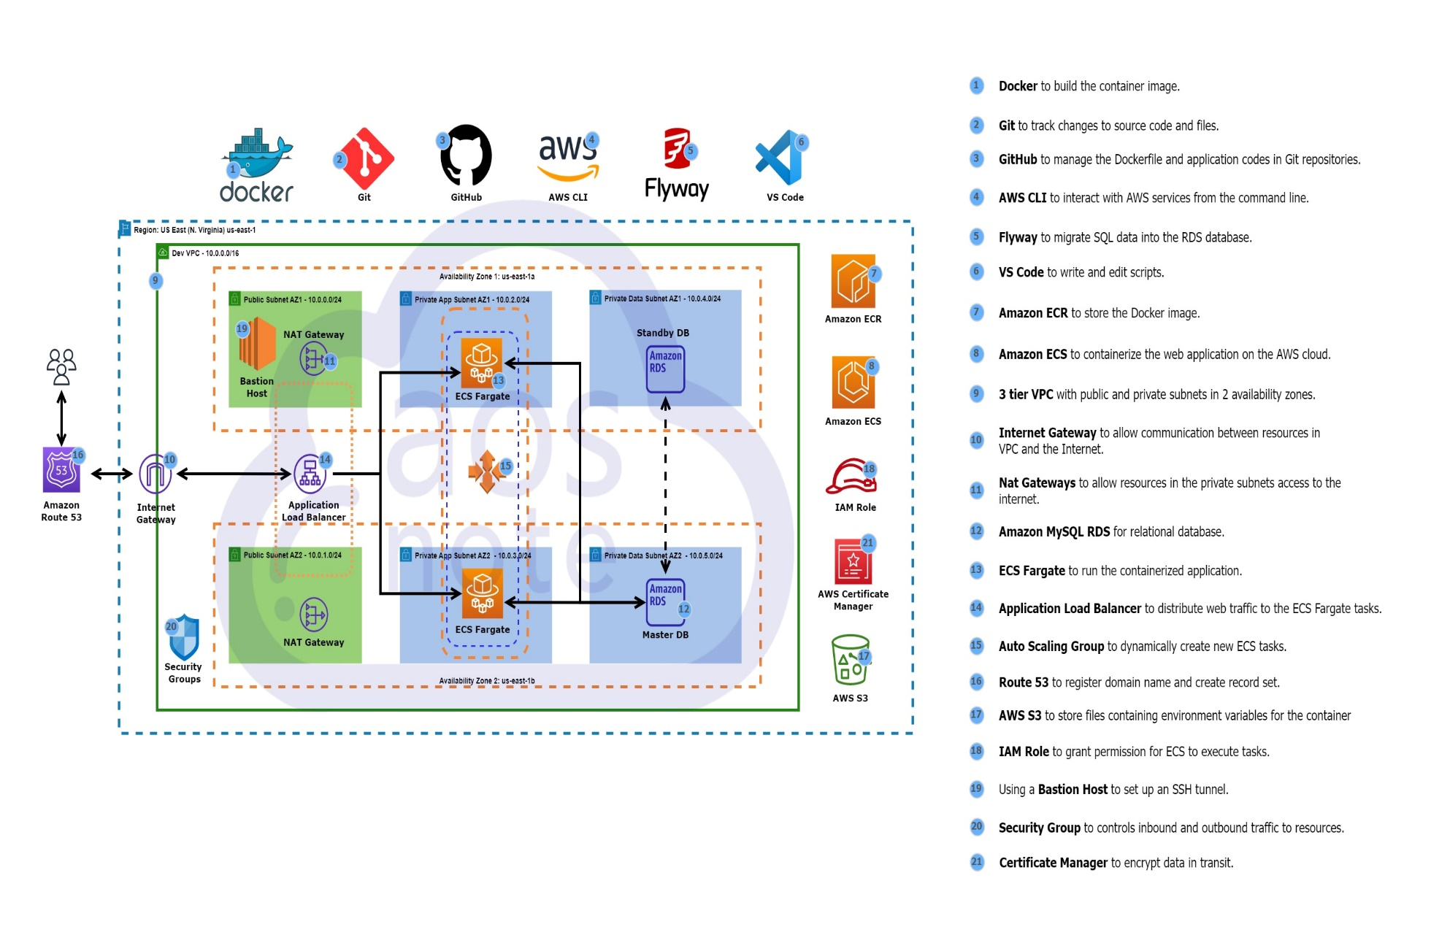

Project 18: CICD Pipeline Kubernetes

